CS550 Final Project Proposal

Name : Zhuoling Chen

E-mail: [chenz6@oregonstate.edu](mailto:chenz6@oregonstate.edu)

For the final project, I want to build a bedroom and study room. It may like this, but not exactly same.

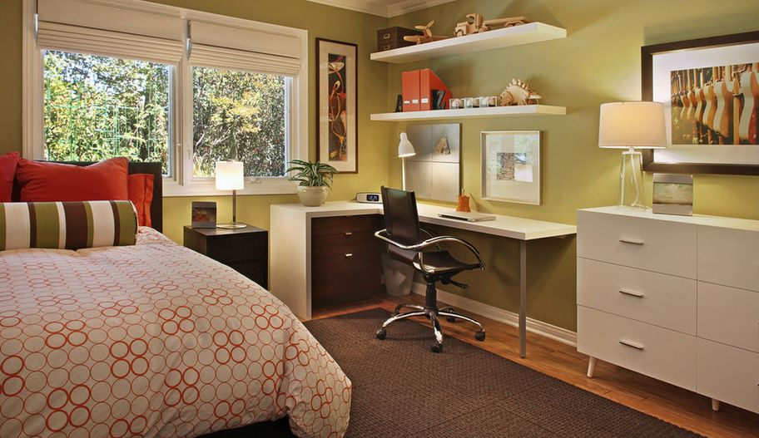

Reference: <https://www.homedit.com/turn-your-room-into-a-study-place-but-still-have-it-be-your-room/bedroom-guest-room-study-are/>

In order to build my final project, I need to use these methods.

1.Load some .obj files, which includes door, window, chair, desk, lamp and so on--Load Object

2.Give the texture for those things--Texture Map

3. Put them into the appropriate place--Transformed

4. Add the outside picture for window view or can be a sunlight and add animation to sunlight

5. Set the sport light for each lamp--Light

6. Use the animation function to change the bed sheet(or some other thing)-- Animation

7. Has an excellence outside view which can look the whole room--LookAt